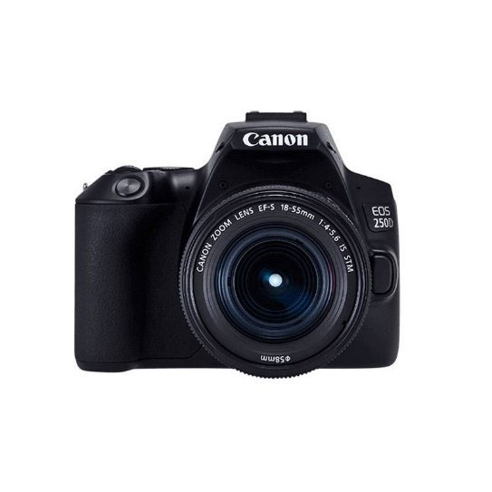



Canon EOS 250D with 18-55mm STM Lens

₨.105,000

Description:

Canon EOS 250D with 18-55mm III Lens Price & Specs
Canon 250d price in Pakistan is nothing short of a miracle. This camera is world’s lightest model with a perfect screen and cutting edge technology. It helps you produce breathtaking photos and 4k videos. This beautiful camera helps you communicate with your smart devices and the settings are easy to get used to.
Inside the camera is a 24.1 MP sensor combine with a DIGIC 8 image processor gives you high quality quick-result even in difficult situations. It comes with an optical view finder that gives you real life view of the world around you. With these features, Canon 250d in Pakistan is definitely worth checking.
The world’s smartest camera comes with a high quality resolution and gives sharp photos. The APS-C sensor produces quality results even in low light. It’s easy to share images with friends and family. Connect the camera with your digital device and it will take care of the rest.
You can capture moments at 5fps or use dual pixel live view with amazing auto focus, you will definitely enjoy the sharpness. Canon 250d price in Pakistan is perfect with all these features. You get point-and-shoot simplicity and movable screen. Not every brand of camera comes with such great features, and on top the camera is light as a feather.
The world's lightest DSLR with movable screen*, with classic handling and cutting-edge technology inside. Great-looking photos and 4K movies are simple to shoot, and the camera communicates intuitively with smart devices.
Small in size, big on features
Inside its portable body, the EOS 250D features a 24.1-megapixel sensor and a DIGIC 8 image processor for superb results on the move. An optical viewfinder gives a clear, real-time view of the world.
The compact DSLR
As the world’s lightest DSLR camera with movable screen*, the EOS 250D can go to more places and be with you more often, for superb results whenever creativity strikes.
Stunning high resolution images and 4K movies
Capture 24.1 megapixel photos and 4K movies that are pin-sharp and packed with colour. An APS-C sized sensor and DIGIC 8 processor ensure great results, even in low light.
Connected to your life
It’s easy to share images with friends and family – just link the EOS 250D to your smartphone or tablet computer* using Bluetooth** and the camera’s built-in Wi-Fi will take care of the rest.
Stay focused, look sharp
Whether you capture the moment at 5fps with the optical viewfinder, or use Dual Pixel CMOS AF Live View with Eye Auto Focus, you can enjoy pin-sharp results.
Simple or advanced?
Enjoy point and shoot simplicity, while Guided UI and Creative Assist mode help unlock your creativity.
The movable touchscreen makes awkward angles and selfies easy.
What’s in the box
Everything you need to capture the moment on your special occasions, just add a memory card and camera case
- Digital Camera EOS 250D body
- Eyecup EF
- Camera Cover R-F-3
- Wide Strap EW-400D-N
- Battery Charger LC-E17E
- Battery Pack LP-E17
- Power Cable
- User Manual Kit

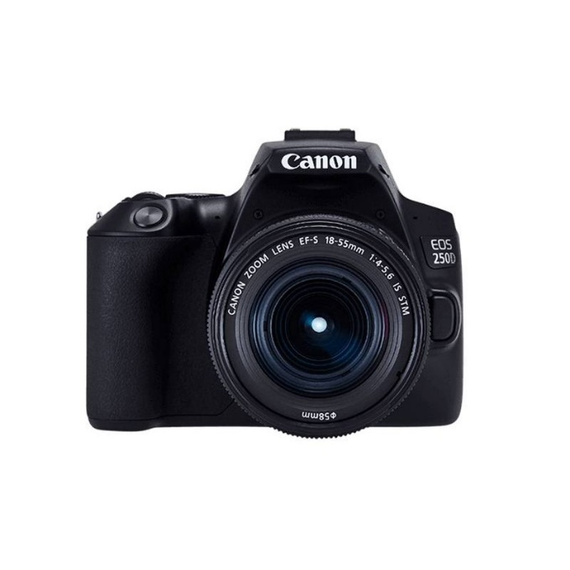
Pictures:
